Chen Primes
# Source: AI Source: Provided by: [Data Path: Persons Table -> ID Column: 1, Name_En Column: Motasem Essam] -> From: [ChatGPT] on [7/13/2026]
A Chen prime is a prime number $p$such that $p+2$is either:
- a prime number, or
- a semiprime (the product of exactly two prime numbers, not necessarily distinct).
Chen primes were introduced by the Chinese mathematician Chen Jingrun in 1966 during his work on problems related to the Twin Prime Conjecture.
Chen primes are studied in number theory, analytic number theory, and prime number distribution.

Definition

Definition:
# Source: AI Source: Provided by: [Data Path: Persons Table -> ID Column: 1, Name_En Column: Motasem Essam] -> From: [ChatGPT] on [7/13/2026]
A Chen prime is a prime number $p$satisfying one of the following conditions:
$$p+2$$
is
- a prime, or
- a semiprime.
In other words,
$$p+2=q$$
where $q$is prime, or
$$p+2=r×s,$$
where $r$and $s$are prime numbers.

Rules for Chen Primes

1. The Number Must Be Prime
# Source: AI Source: Provided by: [Data Path: Persons Table -> ID Column: 1, Name_En Column: Motasem Essam] -> From: [ChatGPT] on [7/13/2026]
The starting number must be prime.
Example
$$11$$
is prime.

2. Compute $p+2$
# Source: AI Source: Provided by: [Data Path: Persons Table -> ID Column: 1, Name_En Column: Motasem Essam] -> From: [ChatGPT] on [7/13/2026]
Add
$$2$$
to the prime.
Example
For
$$11, \\ 11+2=13.$$

3. $p+2$Must Be Prime or Semiprime
# Source: AI Source: Provided by: [Data Path: Persons Table -> ID Column: 1, Name_En Column: Motasem Essam] -> From: [ChatGPT] on [7/13/2026]
If the result is either a prime or a semiprime, then $p$is a Chen prime.
Example
$$13$$
is prime.
Therefore,
$$11$$
is a Chen prime.

4. If $p+2$Is Neither Prime Nor Semiprime, Then $p$Is Not a Chen Prime
# Source: AI Source: Provided by: [Data Path: Persons Table -> ID Column: 1, Name_En Column: Motasem Essam] -> From: [ChatGPT] on [7/13/2026]
Example
Consider
$$43. \\ 43+2=45.$$
Since
$$45=3^{2}×5,$$
it has three prime factors (counting multiplicity), so it is not a semiprime.
Therefore,
43 is not a Chen prime.

5. Every Twin Prime Is Automatically a Chen Prime
# Source: AI Source: Provided by: [Data Path: Persons Table -> ID Column: 1, Name_En Column: Motasem Essam] -> From: [ChatGPT] on [7/13/2026]
If
$$p$$
and
$$p+2$$
are both prime,
then
$$p$$
is both
- a twin prime, and
- a Chen prime.
However, not every Chen prime is a twin prime.

6. Chen Primes Are Believed to Be Infinite
# Source: AI Source: Provided by: [Data Path: Persons Table -> ID Column: 1, Name_En Column: Motasem Essam] -> From: [ChatGPT] on [7/13/2026]
In 1973, Chen Jingrun proved that there are infinitely many Chen primes.
This is a celebrated theorem in analytic number theory.

First Chen Primes
# Source: AI Source: Provided by: [Data Path: Persons Table -> ID Column: 1, Name_En Column: Motasem Essam] -> From: [ChatGPT] on [7/13/2026]
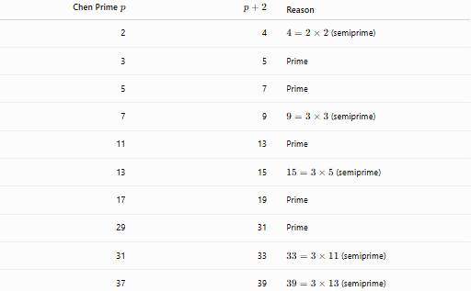
Chen Prime $p$ | $$p+2$$ | Reason
2 | 4 | $4=2×2$(semiprime)
3 | 5 | Prime
5 | 7 | Prime
7 | 9 | $9=3×3$(semiprime)
11 | 13 | Prime
13 | 15 | $15=3×5$(semiprime)
17 | 19 | Prime
29 | 31 | Prime
31 | 33 | $33=3×11$(semiprime)
37 | 39 | $39=3×13$(semiprime)

Examples
# Source: AI Source: Provided by: [Data Path: Persons Table -> ID Column: 1, Name_En Column: Motasem Essam] -> From: [ChatGPT] on [7/13/2026]
Example 1
Determine whether
$$11$$
is a Chen prime.
$$11+2=13.$$
Since
$$13$$
is prime,
11 is a Chen prime.

Example 2
Determine whether
$$13$$
is a Chen prime.
$$13+2=15.$$
Since
$$15=3×5,$$
15 is a semiprime.
Therefore,
13 is a Chen prime.

Example 3
Determine whether
$$7$$
is a Chen prime.
$$7+2=9.$$
Since
$$9=3×3,$$
9 is a semiprime.
Therefore,
7 is a Chen prime.

Example 4
Determine whether
$$43$$
is a Chen prime.
$$43+2=45.$$
Since
$$45=3^{2}×5,$$
45 is not a semiprime.
Therefore,
43 is not a Chen prime.

Example 5
Determine whether
$$31$$
is a Chen prime.
$$31+2=33.$$
Since
$$33=3×11,$$
33 is a semiprime.
Therefore,
31 is a Chen prime.

Example 6
Determine whether
$$59$$
is a Chen prime.
$$59+2=61.$$
Since
$$61$$
is prime,
59 is a Chen prime.

Common Chen Primes
# Source: AI Source: Provided by: [Data Path: Persons Table -> ID Column: 1, Name_En Column: Motasem Essam] -> From: [ChatGPT] on [7/13/2026]
Some well-known Chen primes are
$$2, \\ 3, \\ 5, \\ 7, \\ 11, \\ 13, \\ 17, \\ 29, \\ 31, \\ 37, \\ 41, \\ 59, \\ 71, \\ 101.$$

How to Determine Whether a Number Is a Chen Prime
# Source: AI Source: Provided by: [Data Path: Persons Table -> ID Column: 1, Name_En Column: Motasem Essam] -> From: [ChatGPT] on [7/13/2026]
- Verify that the number is prime.
- Compute
$$p+2.$$
- Determine whether
$$p+2$$
is either:
- prime, or
- a semiprime.
- If either condition is satisfied, the number is a Chen prime.
Example
Check
$$37. \\ 37+2=39.$$
Since
$$39=3×13,$$
39 is a semiprime.
Therefore,
37 is a Chen prime.

Real-Life Applications
# Source: AI Source: Provided by: [Data Path: Persons Table -> ID Column: 1, Name_En Column: Motasem Essam] -> From: [ChatGPT] on [7/13/2026]
Chen primes are primarily used in:
- Analytic number theory research
- Prime gap studies
- Sieve methods
- Computational mathematics
- Prime number algorithms
- Mathematical software
- Computer science
- Mathematics education
- Research on prime distributions

Real-Life Examples
# Source: AI Source: Provided by: [Data Path: Persons Table -> ID Column: 1, Name_En Column: Motasem Essam] -> From: [ChatGPT] on [7/13/2026]
1. Analytic Number Theory
Chen primes play an important role in studying the distribution of prime numbers.

2. Chen's Theorem
Chen Jingrun proved that there are infinitely many primes $p$for which $p+2$is either prime or semiprime. This result is one of the strongest known approximations to the Twin Prime Conjecture.

3. Computational Mathematics
Algorithms search for Chen primes to analyze patterns in prime numbers.

4. Prime Gap Research
Chen primes provide insight into how often prime numbers occur close together.

5. Recreational Mathematics
Chen primes are a fascinating extension of the idea of twin primes.

6. Mathematics Education
They illustrate how broadening a definition (allowing semiprimes as well as primes) can lead to powerful mathematical theorems.

Common Mistakes
# Source: AI Source: Provided by: [Data Path: Persons Table -> ID Column: 1, Name_En Column: Motasem Essam] -> From: [ChatGPT] on [7/13/2026]
- Confusing Chen primes with twin primes.
- Forgetting that $p+2$may be a semiprime, not necessarily a prime.
- Thinking every Chen prime belongs to a twin prime pair.
- Mistaking numbers with more than two prime factors for semiprimes.
- Forgetting that the original number must itself be prime.

Key Points
# Source: AI Source: Provided by: [Data Path: Persons Table -> ID Column: 1, Name_En Column: Motasem Essam] -> From: [ChatGPT] on [7/13/2026]
- A Chen prime is a prime $p$such that $p+2$is prime or semiprime.
- Every twin prime is a Chen prime.
- Not every Chen prime is a twin prime.
- Chen primes were introduced by Chen Jingrun.
- Chen's Theorem proves that there are infinitely many Chen primes.
- Chen primes are an important topic in analytic number theory and prime gap research.

Chen Primes vs. Twin Primes
# Source: AI Source: Provided by: [Data Path: Persons Table -> ID Column: 1, Name_En Column: Motasem Essam] -> From: [ChatGPT] on [7/13/2026]
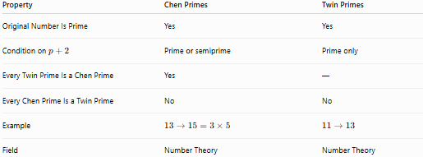
Property | Chen Primes | Twin Primes
Original Number Is Prime | Yes | Yes
Condition on $p+2$ | Prime or semiprime | Prime only
Every Twin Prime Is a Chen Prime | Yes | —
Every Chen Prime Is a Twin Prime | No | No
Example | $$13→15=3×5$$ | $$11→13$$
Field | Number Theory | Number Theory

Chen Primes vs. Safe Primes
# Source: AI Source: Provided by: [Data Path: Persons Table -> ID Column: 1, Name_En Column: Motasem Essam] -> From: [ChatGPT] on [7/13/2026]
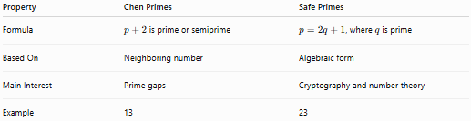
Property | Chen Primes | Safe Primes
Formula | $p+2$is prime or semiprime | $p=2q+1$, where $q$is prime
Based On | Neighboring number | Algebraic form
Main Interest | Prime gaps | Cryptography and number theory
Example | 13 | 23

Conclusion
# Source: AI Source: Provided by: [Data Path: Persons Table -> ID Column: 1, Name_En Column: Motasem Essam] -> From: [ChatGPT] on [7/13/2026]
A Chen prime is a prime number $p$for which $p+2$is either prime or a semiprime. This concept generalizes twin primes by allowing the second number to have exactly two prime factors instead of requiring it to be prime. Introduced by Chen Jingrun, Chen primes are central to analytic number theory because Chen's Theorem proves that there are infinitely many such primes, making it one of the strongest known results related to the Twin Prime Conjecture.

